Task – 1: Create a virtual machine
Step 1: In the below image, I have filled out the basic details such as the resource group, name and image for the virtual machine
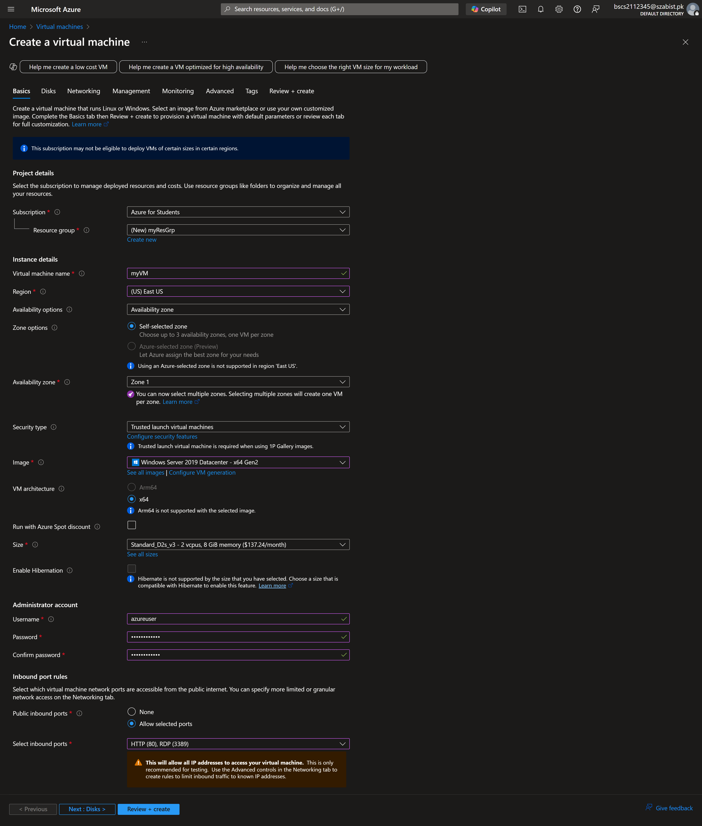

Step 2: Selecting inbound ports 80 and 3389 for the virtual machine
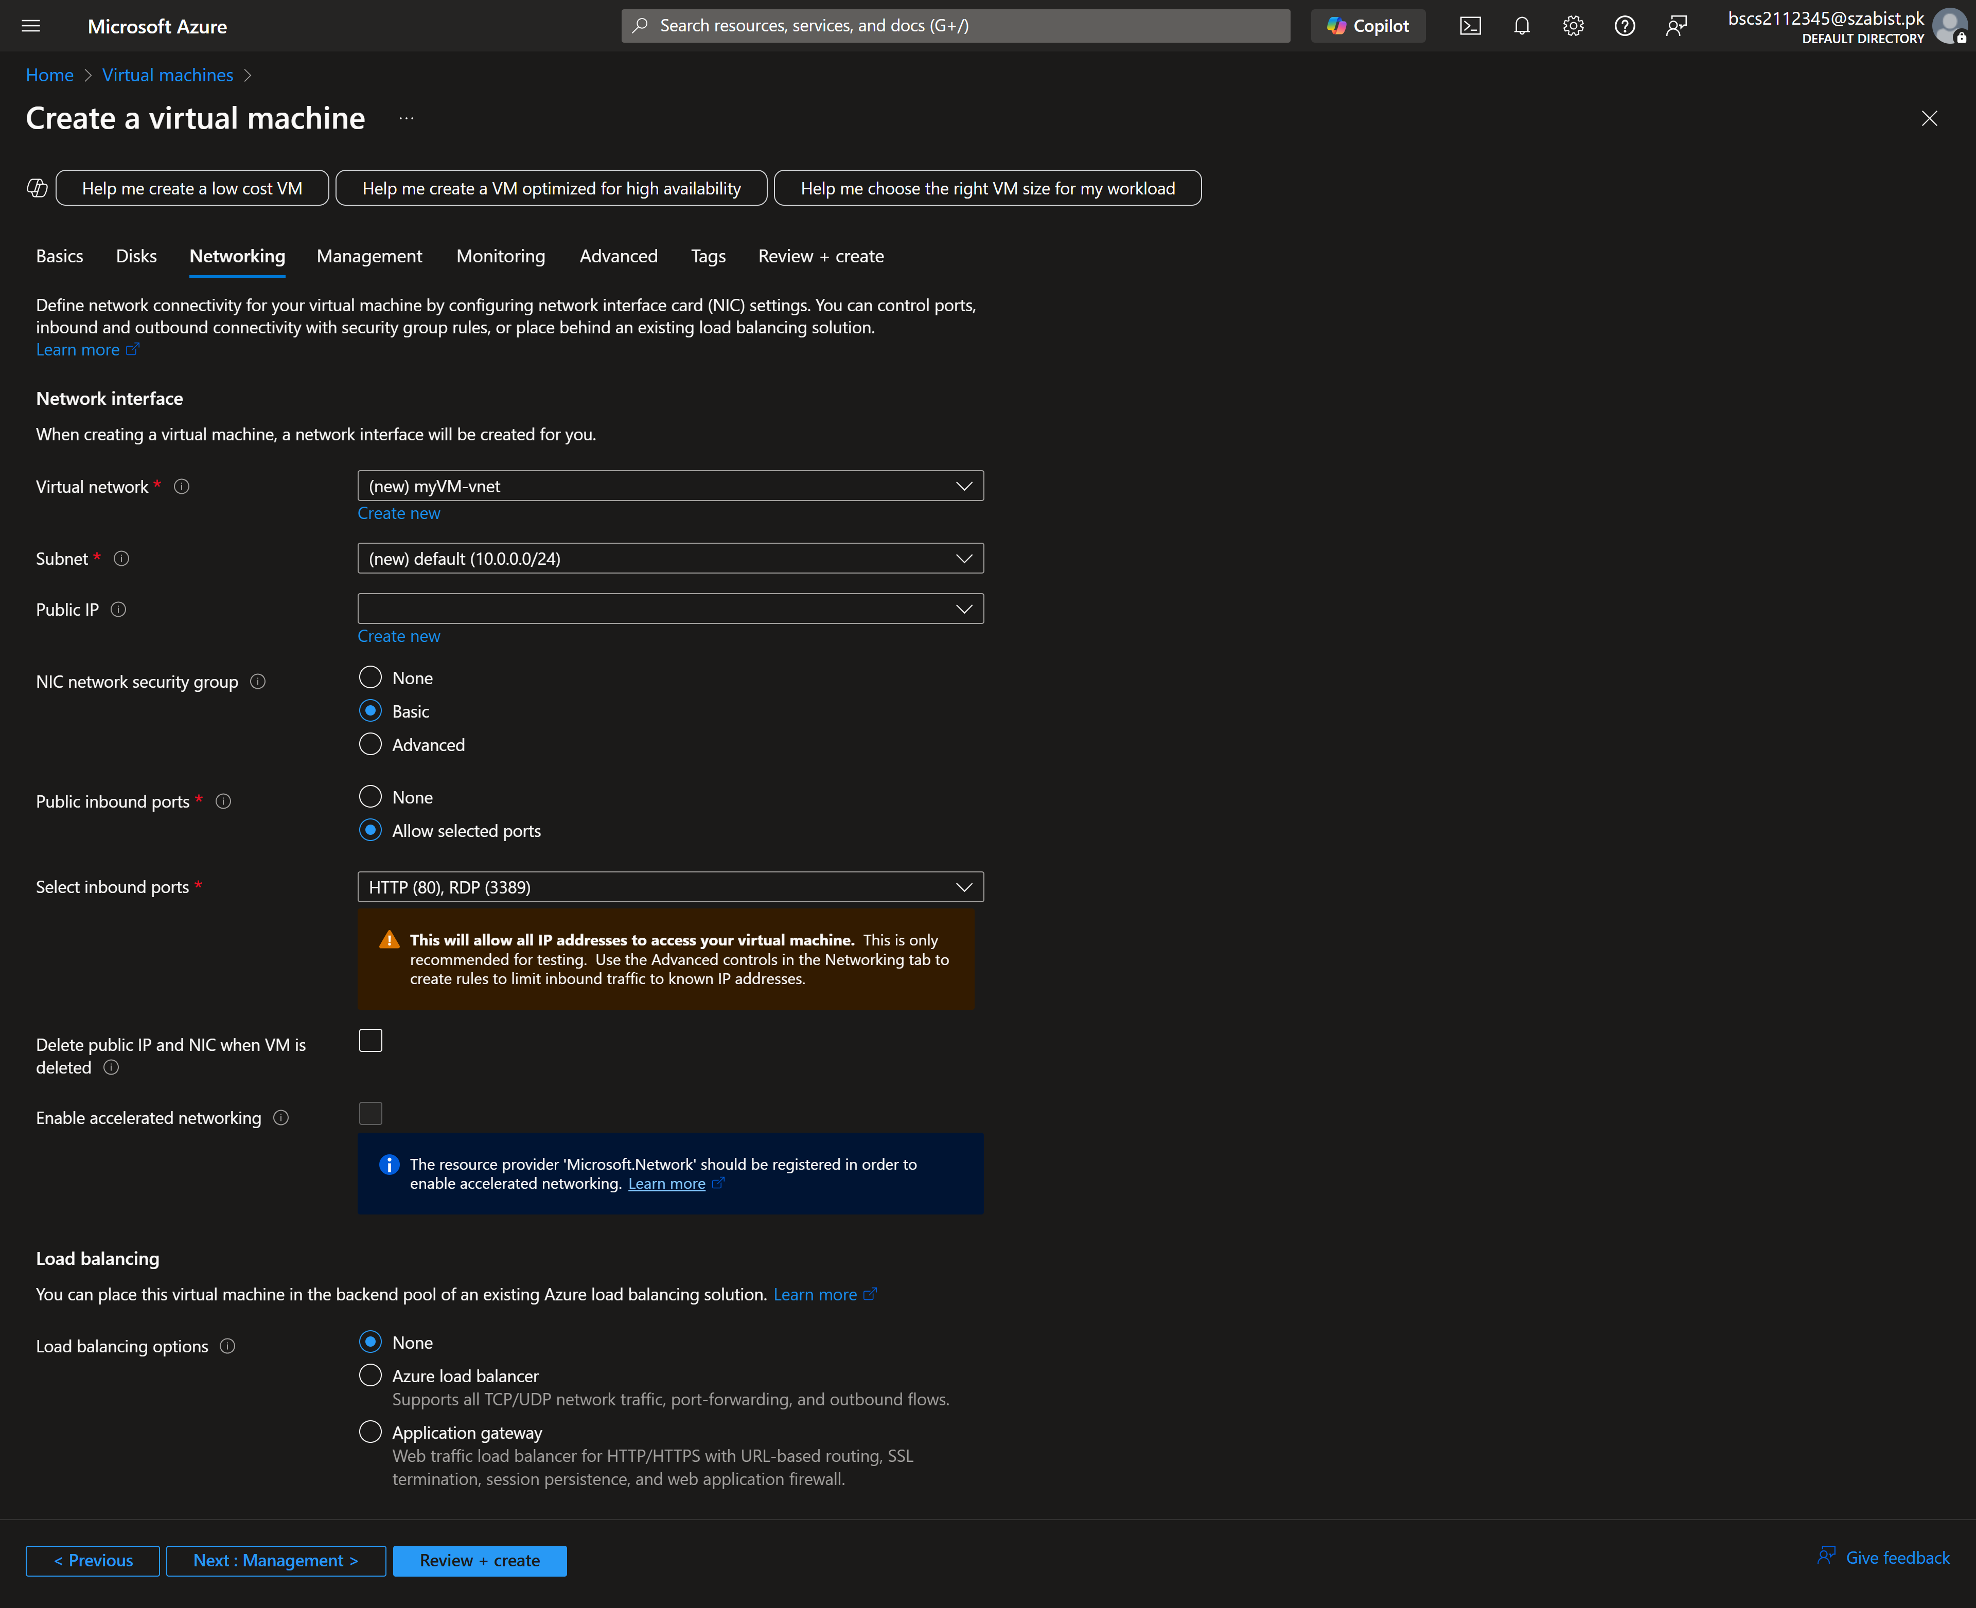
Step 3: Disabling the boot diagnostics for the virtual machine
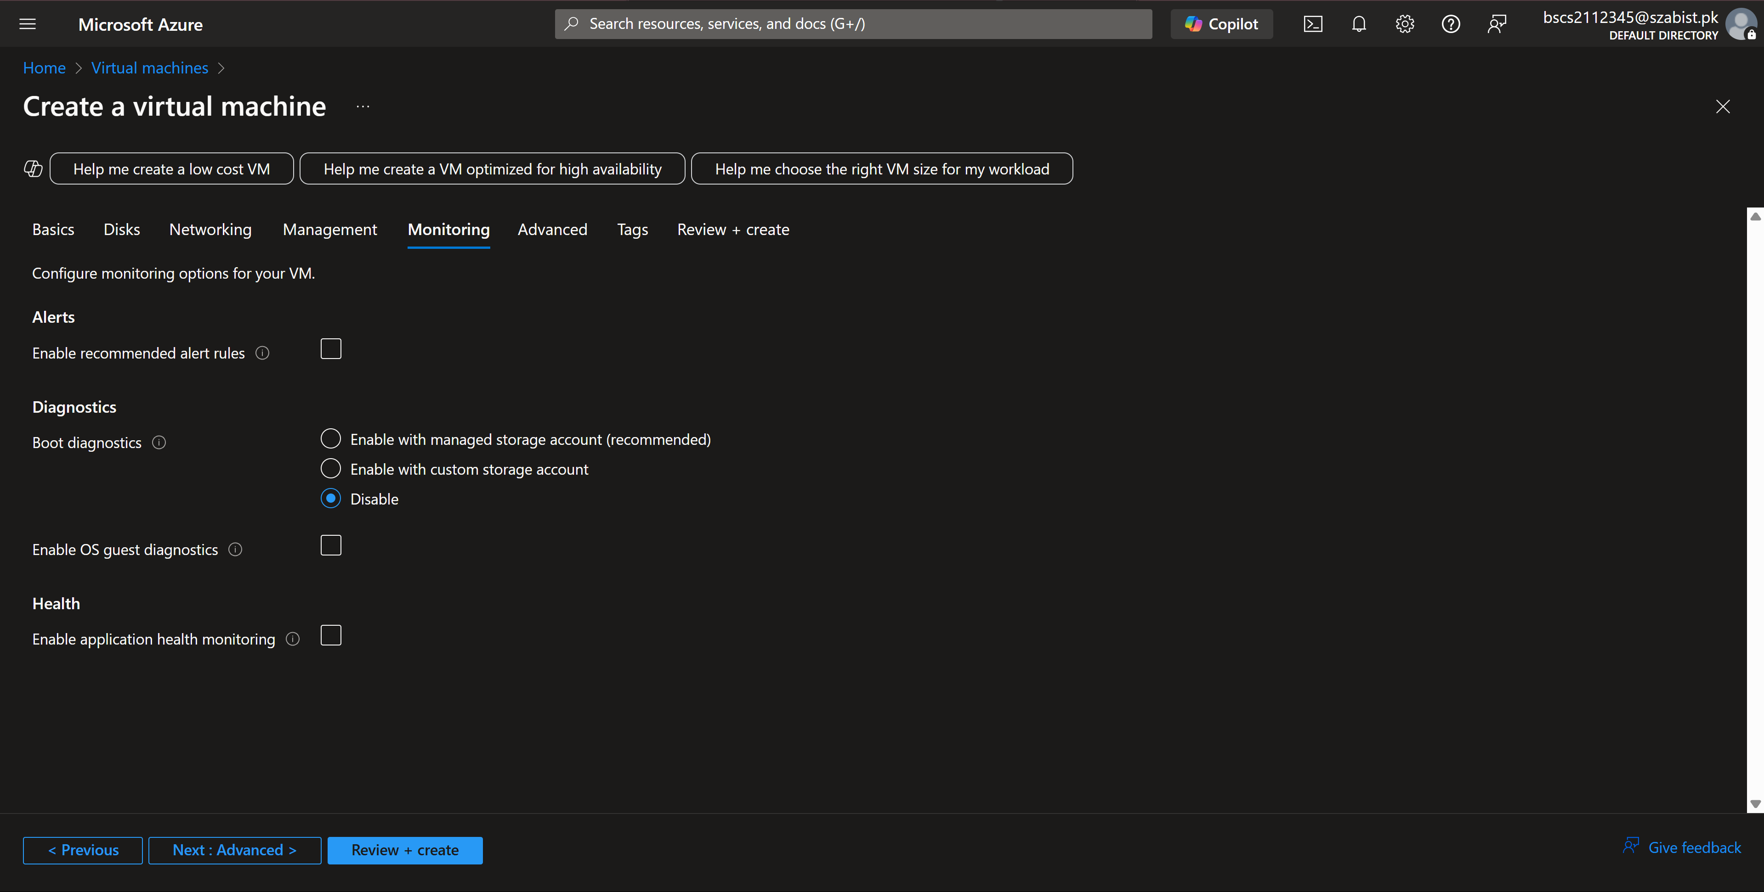

Step 4: The below image displays the complete configuration of the virtual machine and has passed the validation checks
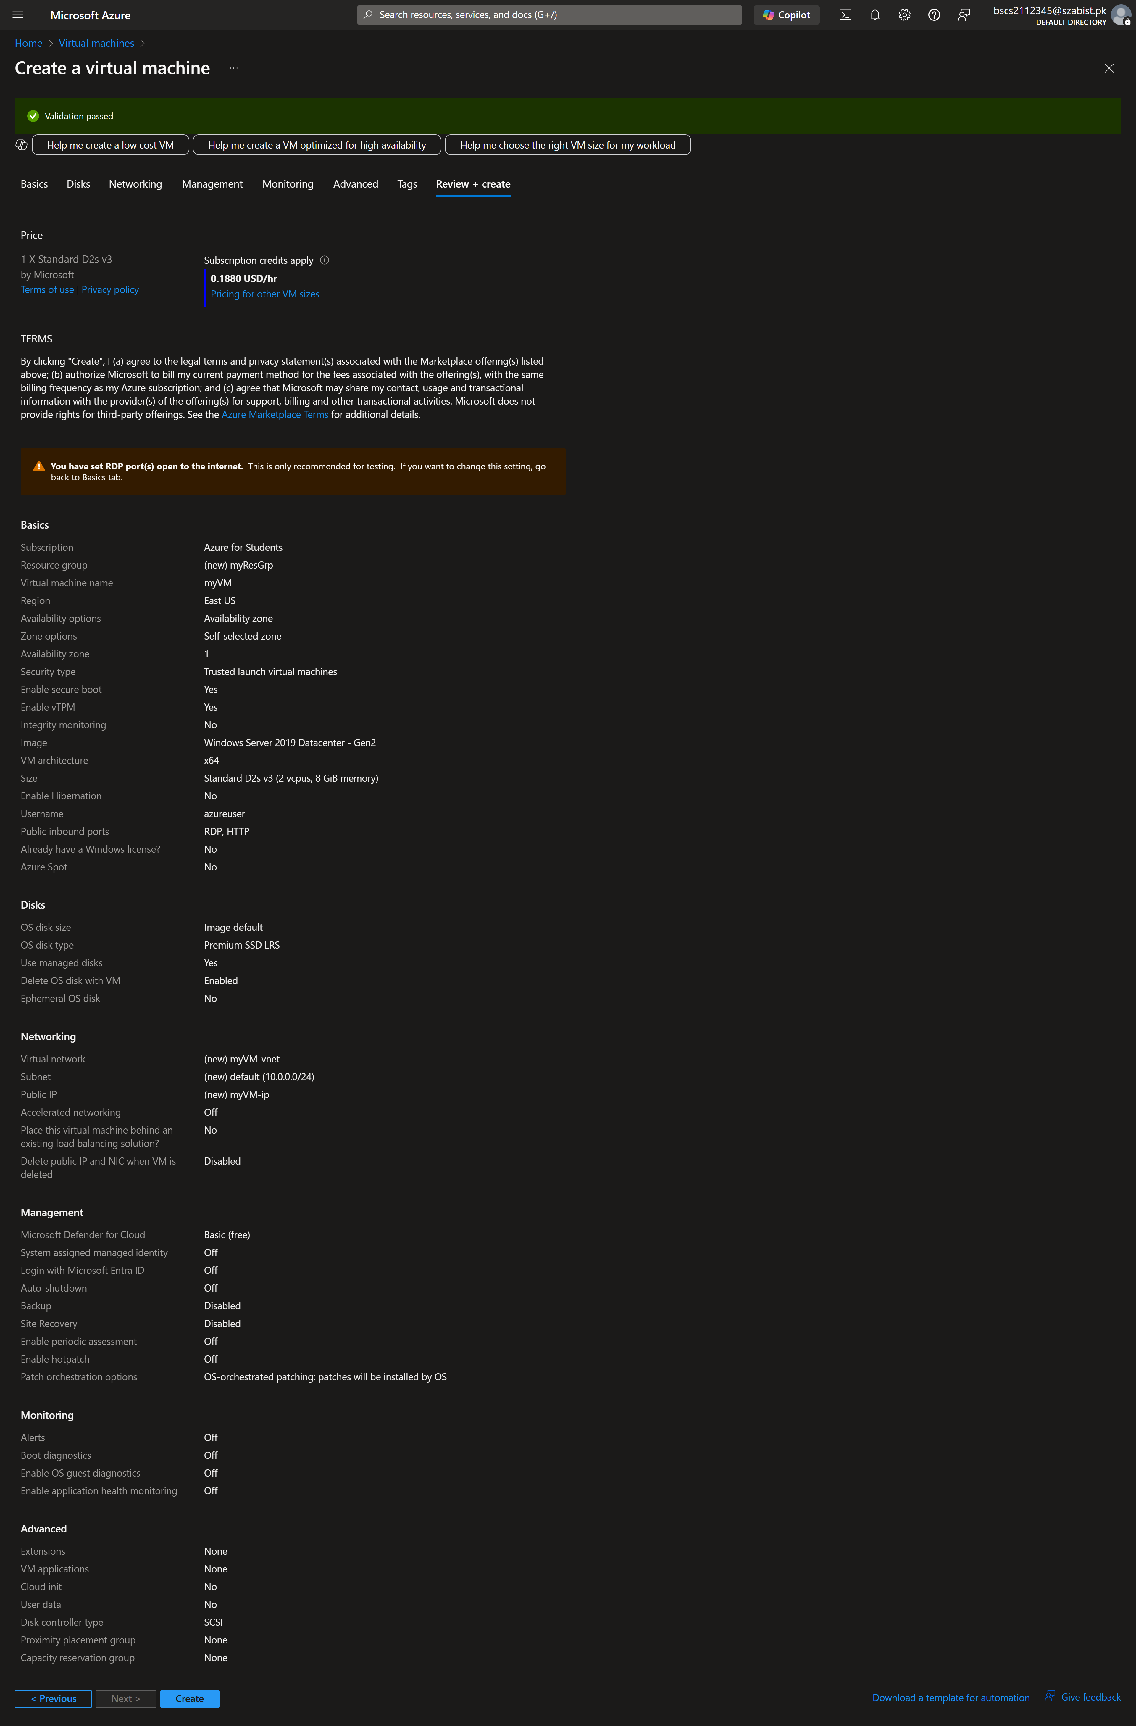
Step 5: The below image displays the successful deployment of the VM
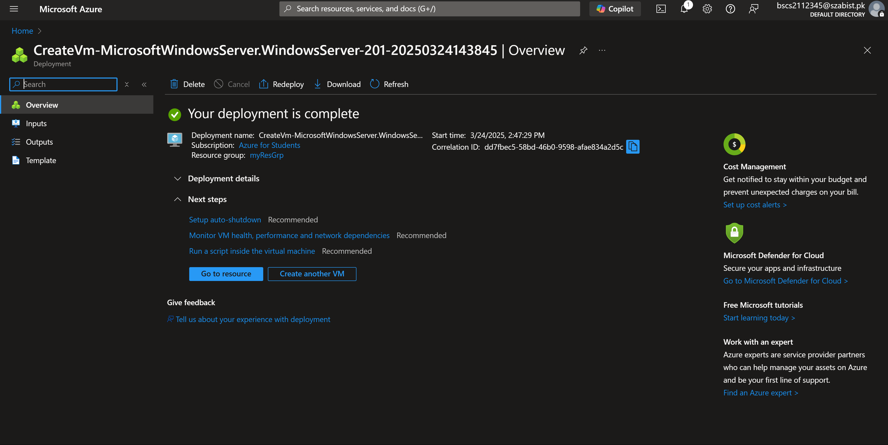

Task 2: Accessing VM through RDP
Step 1: accessing the connection options for vm
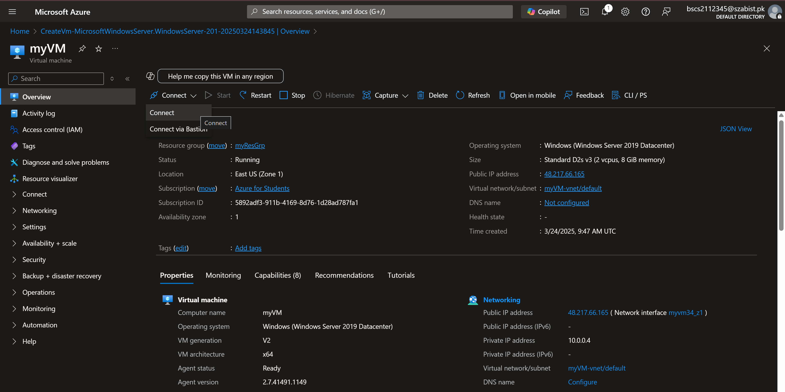
Step 2: Download the RDP file to access the VM
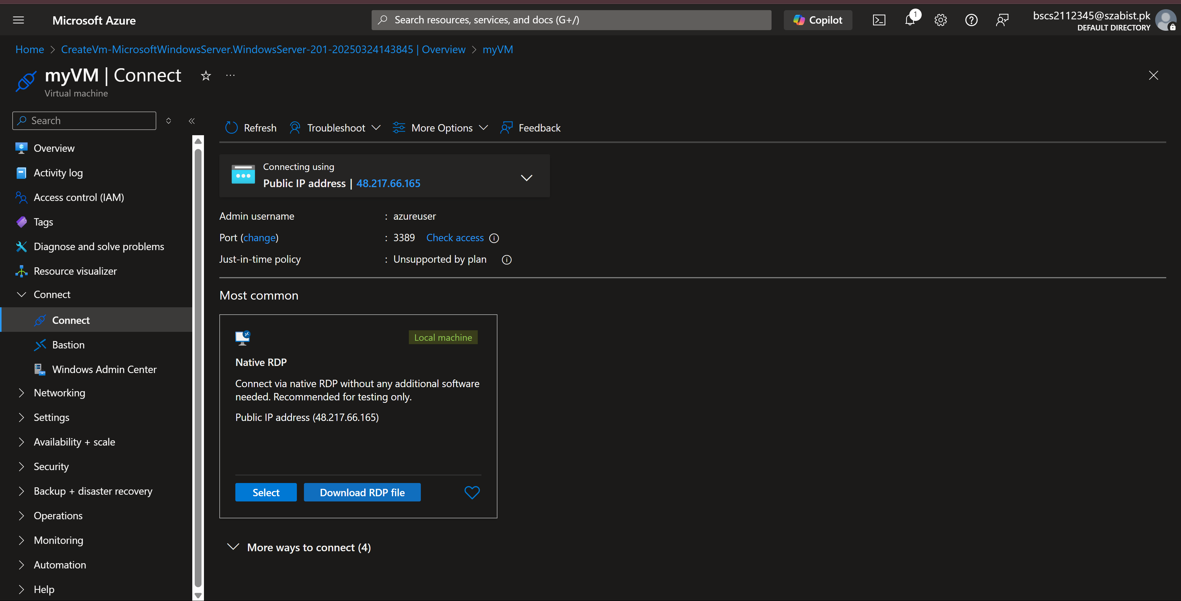

Step 3: connecting to the VM using RDP file
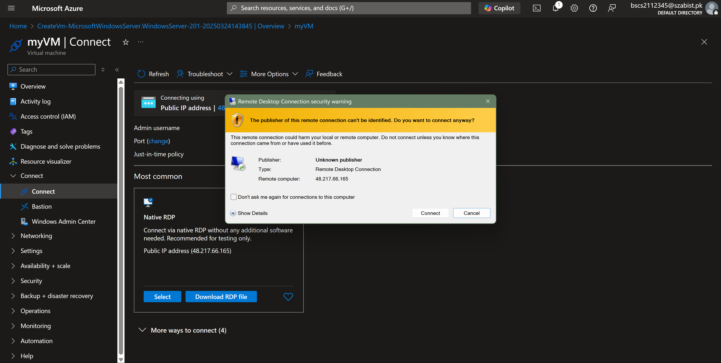
Step 4: VM is accessed and is having the server manager maximized.
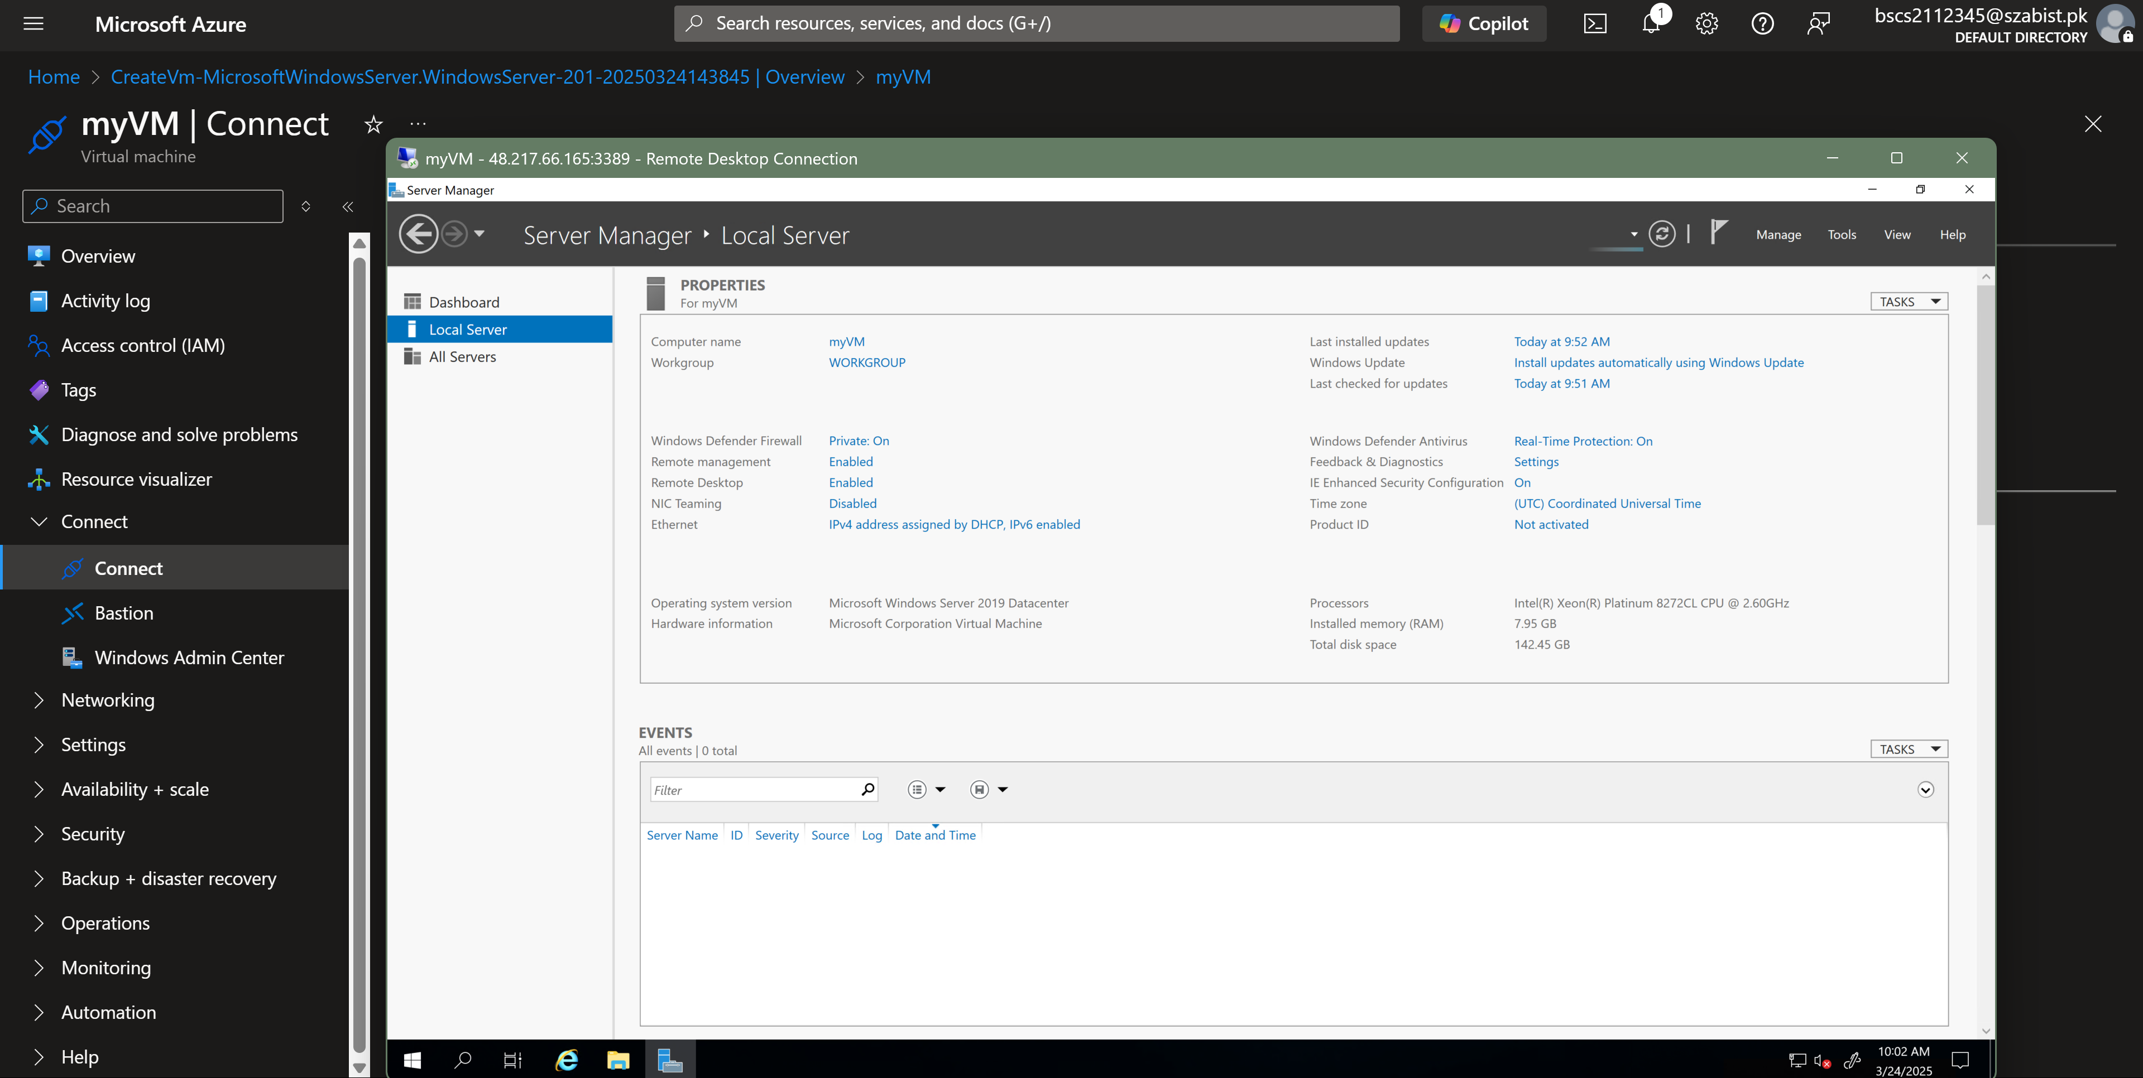

Task – 3: Installing IIS web server
Step 1: Installing IIS web server on VM
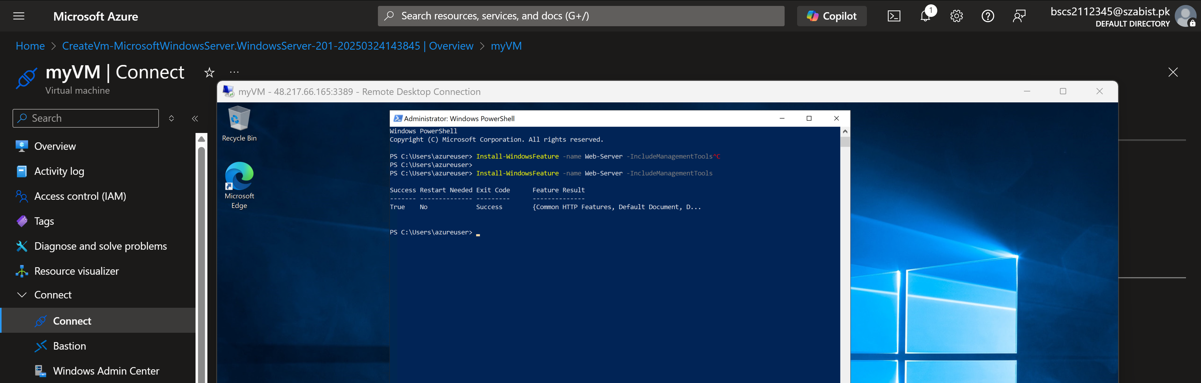
Step 2: Accessing IIS web server through public IP
